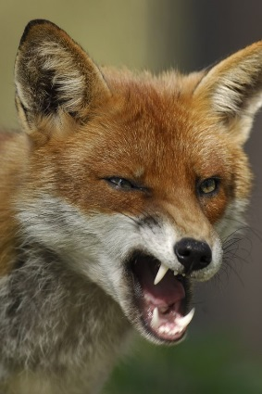

mirror. (2016). *Denise Welch's dog savaged by fox which had strayed into her kitchen.* Available: https://www.pinterest.com/angielaneparker/foxy-like-a-fox/. Last accessed 18/10/2016.



thedailywtf. (2015). *The Fox Ideas Thread.* Available: [https://what.thedailywtf.com/topic/14061/the-fox-ideas-thread/884. Last accessed 18/10/2016](https://what.thedailywtf.com/topic/14061/the-fox-ideas-thread/884.%20Last%20accessed%2018/10/2016).

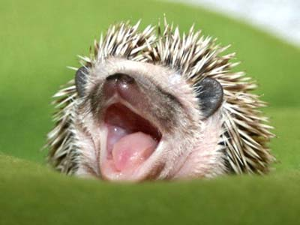

gardenofeden. (2012). *The Hedgehog Facts.* Available: http://gardenofeaden.blogspot.co.uk/2012/08/the-hedgehog.html. Last accessed 18/10/2016.

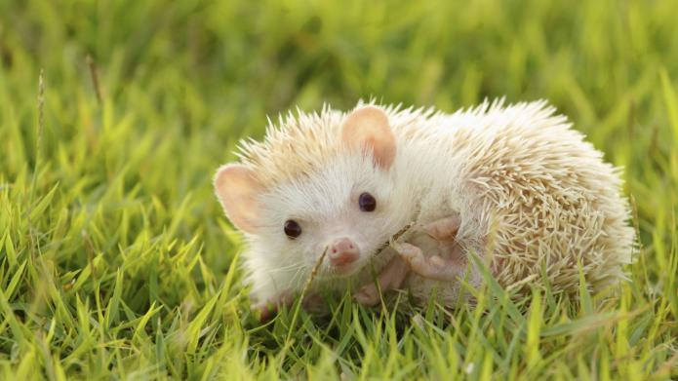

Kristen Fischer. (2014). *10 Fun games you can play with your hedgehog.* Available: http://www.sheknows.com/pets-and-animals/articles/1032979/fun-games-you-can-play-with-your-hedgehog. Last accessed 18/10/2016.

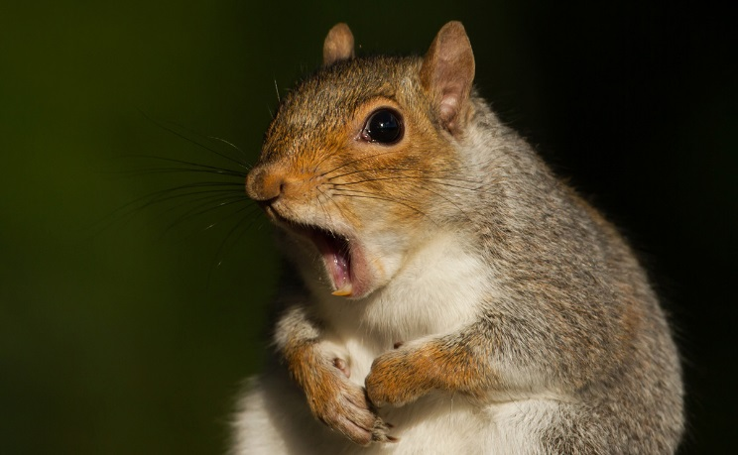

Elka Karl. (2014). *New Year’s Resolution: Eat More Squirrel in 2015.*Available: http://modernfarmer.com/2014/12/new-years-resolution-eat-squirrel-2015/. Last accessed 18/10/2016.



Chunyan Wang. (2016). *Everything in Japan is cuter.* Available: https://www.pinterest.com/explore/cute-squirrel/. Last accessed 18/10/2016.



pinterest. (2016). *Snow Grey.* Available: https://www.pinterest.com/ubergek/squirrels/. Last accessed 18/10/2016.

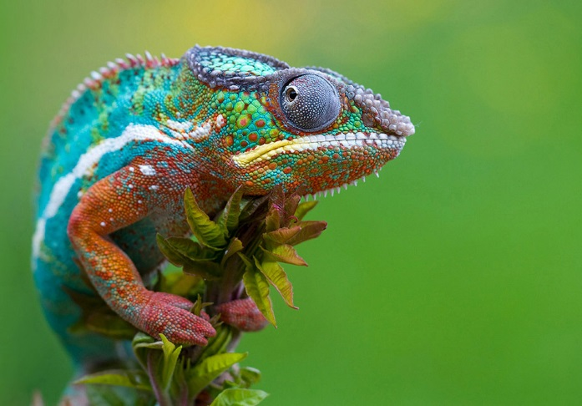

ectotherms. (2016). *Chameleons - S.S.* Available: http://ectotherms.wikia.com/wiki/Chameleon_-_S.S. Last accessed 18/10/2016.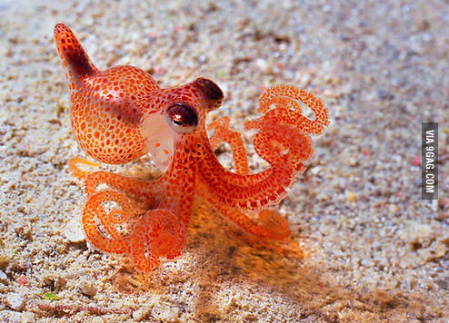

9gag. (2016). *Cute octopus.* Available: http://9gag.com/gag/5533082/cute-octopus. Last accessed 18/10/2016.

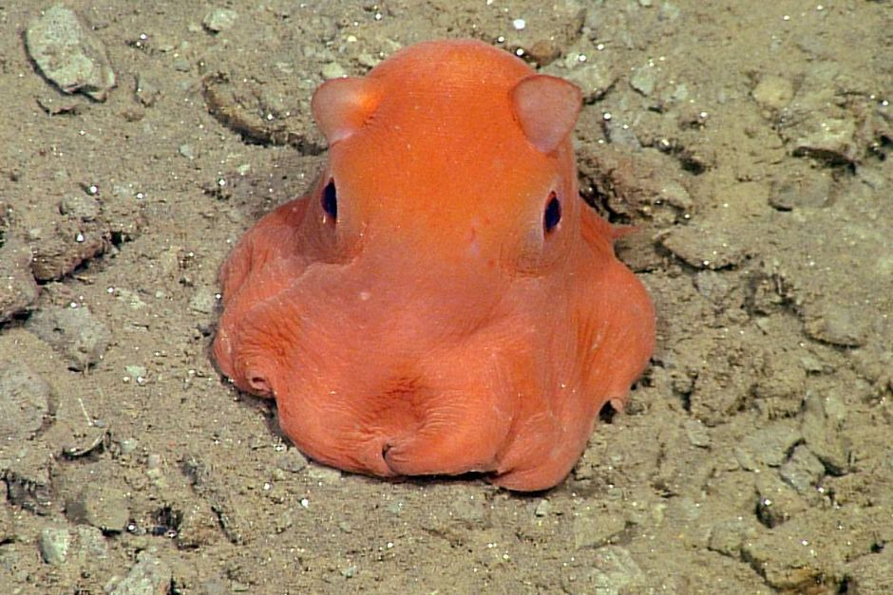

abc. (2015). *Tiny octopus so cute scientists want to name it 'adorabilis'.* Available: http://www.abc.net.au/news/2015-06-18/octopus-so-cute-scientists-want-to-name-it-adorabilis/6555062. Last accessed 18/10/2016.

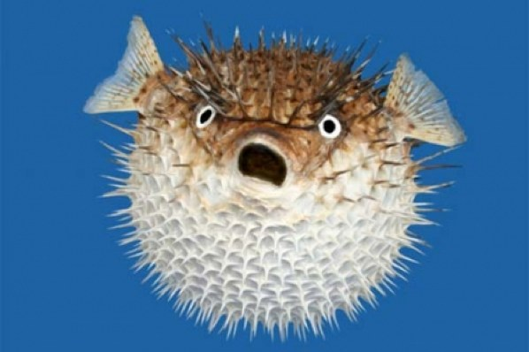

codeavengers. (2016). *Phenomenal Pufferfish - The best fish in the world.* Available: https://www.codeavengers.com/c/cp56/page1.html. Last accessed 18/10/2016.